Great Barrier Reef gets a reprieve from the heat this year
Craig Steinberg and Madeleine Cahill

The GBR has had a welcome reprieve from the heat this year with below-average Sea Surface Temperatures particularly in January and February (see right, 17 Feb SST Percentiles), the time when water temperatures on the reef are usually at their maximum. Since the damaging coral bleaching summers of 2016 and 2017 on the GBR, researchers and managers have paid close attention to the seasonal forecast for SST as summer approaches. Coming into this summer, the November outlook was for moderate warming (0.5°C above average) throughout the GBR but by early December, SST percentiles indicated temperatures turned out to be significantly warmer (in the highest 20%) than the forecast.
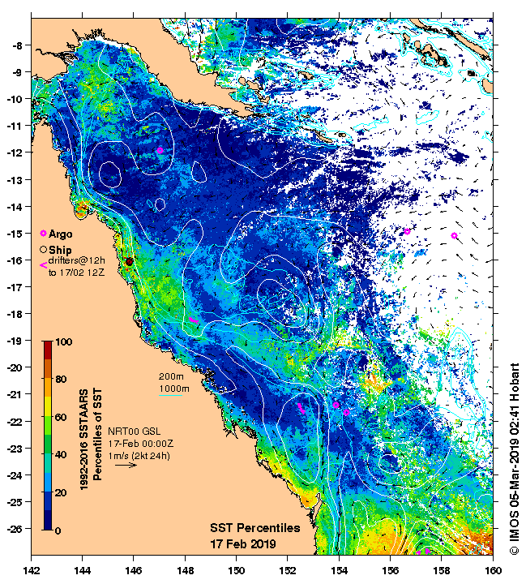

Cyclone Owen, however, put a stop to that when it passed through the region just a few days later and then again on Dec 15. Further heating throughout the summer was limited by the stable monsoon trough that developed over North Queensland and then Tropical Cyclones Penny, Oma and now Trevor. The cyclones and the monsoon both provide heavy cloud cover that blocks solar heating and the strong winds cool the surface by vertically mixing cool water from below the thermocline.

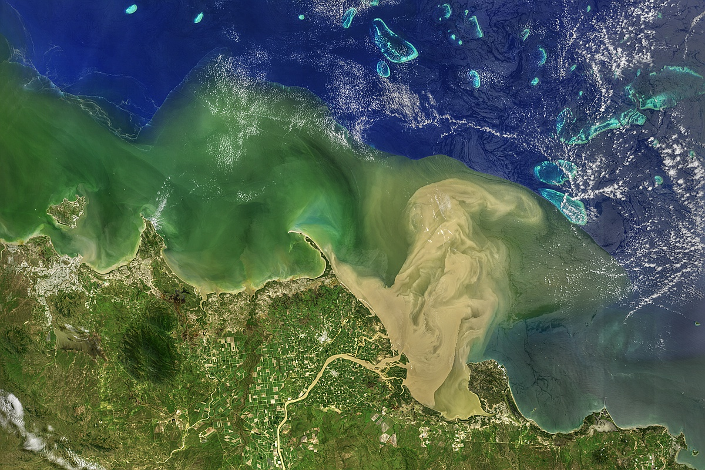

Figure 2. NASA-OBPG's Landsat 8 image of the Burdekin plume, 11 Feb 2019, showing the boundary of the flood plume against the clear ocean waters. (The high resolution image is available at https://oceancolor.gsfc.nasa.gov/gallery/620/)

Of course, monsoons and cyclones also bring rain and this season the rainfall was unprecedented. There was runoff onto the reef all along the coast but particularly from the Burdekin River which has a catchment area west of the Great Dividing Range. On Feb 11, the sediment laden plume was seen to extend 60km across the shelf (Figure 2) and a few days later, after the wind turned offshore, it reached all the way to Gould Reef on the outer shelf. Inshore regions often feel the effects of the runoff plumes but it is unusual for them to affect the outer reef. The sediment in the river plumes will eventually settle out, potentially smothering seagrasses and corals. The plume waters themselves bring nutrients and often result in large increases in microbial and planktonic blooms. On the positive side, benefits include increased prawn production and food for other larvae.

